The Missing Layer of Digital Transformation: Operational Discipline
Digital transformation is reshaping public institutions, but deployment is not the same as transformation.
Across the globe, governments are scaling cloud infrastructure, advanced data systems, and AI tools to improve efficiency and service delivery. What determines success is how these technologies are embedded into operational structures.
The ambition is clear: faster services, better decision-making, and more responsive public institutions.
Yet many digital initiatives struggle to deliver the impact they promise.
In most cases, the issue is not the technology itself.
The challenge lies in something less visible but far more decisive: operational discipline.
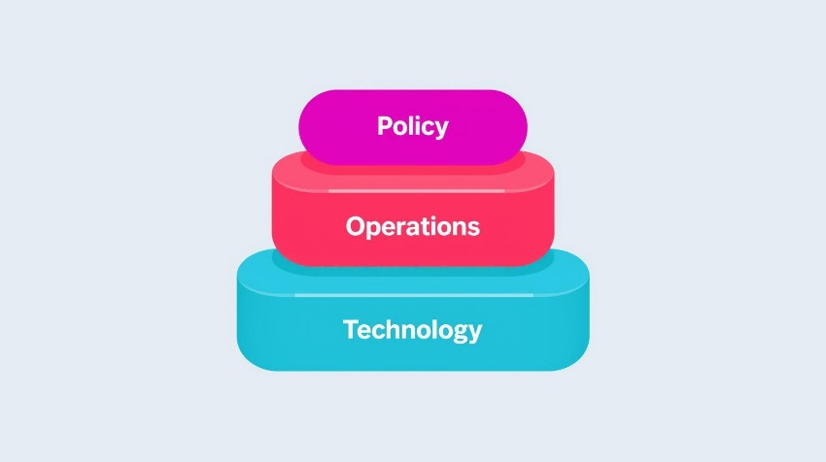

The Three Layers of Sustainable Digital Transformation
Digital transformation in public institutions tends to succeed when three institutional layers evolve together.

Policy Layer
Defines the strategic objectives of transformation and the outcomes governments seek to achieve through digital services.

Operational Layer
Translates strategy into governance structures, processes, and institutional workflows.

Technology Layer
Provides the platforms, systems, and infrastructure that support these processes.
When these layers move in alignment, transformation becomes sustainable.
When they do not, institutions often find themselves with modern technology operating within outdated structures.

Technology Is the Visible Layer, Operations is the Real Engine
Modern digital platforms are powerful, scalable, and increasingly accessible. Governments can deploy sophisticated systems faster than ever before.
But digital transformation is not simply about introducing new tools.
It is about embedding those tools into the everyday functioning of institutions.
Technology must align with policy frameworks, operational workflows, governance structures, and the incentives that shape how organizations actually function.
Without this alignment, systems often become:
- Underutilized
- Poorly configured
- Fragmented across departments
- Detached from the services they were meant to improve
In other words, the technology works but the institution does not transform.



The Strategy–Execution Gap
Many governments today have clear digital strategies.
These strategies often outline ambitious goals such as:
- Seamless citizen services
- Data-driven decision making
- Integrated public systems
- Greater institutional transparency
However, between strategy and outcomes lies execution.
Policies and roadmaps define the destination, but operational systems determine whether institutions actually get there.
Bridging this gap requires clear operational structures:
- Defined ownership of digital platforms
- Regular performance and adoption reviews
- Alignment between policy, IT, and operational teams
- Structured processes for managing system changes
Without these mechanisms, digital initiatives may launch successfully but struggle to generate sustained institutional impact.



Governance Is Infrastructure
When digital infrastructure is discussed, the focus is often on platforms, networks, and data architecture.
But governance is just as important.
Governance determines how systems evolve, who owns them, and how decisions about their configuration and development are made.
Organizations that succeed in digital transformation treat governance as part of the system itself.
This includes:
- Defined accountability for digital platforms
- Structured decision-making around system changes
- Regular governance and performance reviews
- Clear escalation paths when operational issues arise
Without governance, digital environments tend to fragment over time.

Teams introduce independent tools, duplicate platforms are deployed for similar functions, and data flows become disconnected across departments.

In practice, this can look like:
- Multiple case management systems handling similar workflows
- Separate cloud instances operating without integration
- Manual data transfers between platforms because APIs were never aligned
Operational discipline prevents this fragmentation by enforcing platform ownership, standardized configurations, and structured oversight ensuring systems remain aligned with institutional priorities.

Transformation Is Sustained Through Operations
One of the most persistent misconceptions about digital transformation is that it is a project.
Projects have launch dates and completion milestones.
Transformation does not.
Transformation is sustained through continuous operational management.
Systems must be monitored, workflows refined, configurations adjusted, and performance evaluated. These activities ensure digital platforms remain aligned with evolving policy priorities and service delivery needs.
Operational teams often working quietly behind the scenes play a central role in ensuring that digital platforms become institutional capabilities rather than temporary initiatives.

Lessons from Leading Digital Governments
Countries that have successfully advanced digital government capabilities demonstrate the importance of operational alignment.
For example, the United States Digital Service was established within the White House to improve federal digital services by embedding modern technology practices, service standards, and governance principles directly into government projects. A key early success was leading the recovery of HealthCare.gov after its failed launch, demonstrating how strong operational practices, user-centered design, and disciplined technology delivery can turn around critical public services. In addition to technology work, USDS produced the Digital Services Playbook, a set of practices for building effective digital government services, and influenced how multiple federal agencies approach digital transformation and platform delivery

From Technology Adoption to Institutional Capability
At its core, digital transformation is not simply about implementing systems.
It is about building institutions that can operate effectively in a digital environment.
Organizations that succeed focus on strengthening the structures that support technology:
- governance frameworks
- operational ownership
- performance monitoring
- cross-departmental coordination
When these foundations are in place, technology becomes a powerful enabler of better services and more resilient institutions.
Without them, even the most advanced systems struggle to achieve their intended impact.

Closing Reflection
Digital transformation is often framed as a technology challenge.
In reality, it is an institutional discipline.
Technology may enable change, but operations determine whether that change endures.
“Digital transformation is not achieved when systems go live, it is achieved when institutions learn how to operate them.”

